Web Basics - JavaScript
Lab Book

Document Revision History

Date | Revision No. | Author | Summary of Changes
12-May-2009 | 1.0 | Pradnya Jagtap | Content Creation
05-Oct-2009 | 1.1 | CLS Team | Review
24-Jun-2010 | 2.0 | Anu Mitra | Refinements
03-May-2011 | 3.0 | Karthik M/Anu Mitra | Integration Refinements
21-Apr-2015 | 4.0 | Rathnajothi P | Revamp/Refinement
15-May-2015 | 5.0 | Kavita D Arora | Integration Refinements
01-july-2017 | 6.0 | Rahul Vikash | Revamped as per BU

Table of Contents
Getting Started 5
Overview 5
Setup Checklist for JavaScript 5
Lab 1: Basics Concepts of JavaScript 6
1.1: Create a page to display “Welcome to JavaScript”. 6
1.2: Create prob2.html to display Formatted Hello World by using JavaScript by embedding Hello World in <H1> tag. 7
1.3: Create page to show use of external JavaScript 8
1.4: Using Variable in many Script tags 11
Lab 2: The JavaScript Language 14
2.1: For loop in JavaScript 14
2.2: Create a web page to calculate the Compound Interest using the formula given below: 15
Lab 3: Working with Predefined core objects 16
3.1: Displaying Date using Date Object 16
3.2: Using indexOf function of String object 17
3.3: Using various String methods 17
Lab 4: Working with Arrays 19
4 .1: Using Array to display values 19
Lab 5: Working with Document Object Model(DOM) 20
5 .1: Window object 20
Lab 6: Working with Location Object 23
6.1: Location Object 23
Lab 7: Working with Document Object 24
7.1: Working with Documents 24
Lab 8: Working with Form Object 27
8.1: Form Validation 27
8.2 Validate Field 28
Lab 9: Regular Expressions in JavaScript 30
9.1: Regular Expression 30
9.2: Form Validation using Regular Expression 32
Appendices 34
Appendix A: JavaScript Standards 34
Appendix B: Coding Best Practices 41
Appendix C: Table of Figures 47
Appendix D: Table of Examples 48

Getting Started

Overview
These Lab book is a guided tour for Learning JavaScript. It contains solved examples and To Do assignments. Follow the steps provided in the solved examples and then work out the ‘to do’ Assignments given.

Setup Checklist for JavaScript
Here is what is expected on your machine in order for the lab to work.
Minimum System Requirements
- Hardware: Networked PCs with minimum 64 MB RAM and 60 MB HDD.
- Software: Window based Operating System having the latest version of Internet Explorer (IE) or Netscape Navigator installed.
Please ensure that the following is done:
- A text editor like Notepad, Eclipse Luna or Visual Studio 2008 is installed.
Instructions
- For coding standards refer Appendix – A.
- All Lab assignments should follow the coding standards.
- Create a directory by your name in drive <drive> for JavaScript assignments.
- In this directory, create subdirectory javascript_assgn.
- For each lab create directory as lab<lab number>.
Learning More (Bibliography if applicable)
- Beginning JavaScript by Paul Wilton
- JavaScript: The Definitive Guide by David Flanagan
- JavaScript Application Cookbook by Jerry Bradenbaugh

- Basics Concepts of JavaScript

Goals | - Learn to embed script tags in different parts of the HTML document.
Time | 120 minutes

1.1: Create a page to display “Welcome to JavaScript”.
Solution:
Step 1: Complete the following code and save it as prob1.html
<!DOCTYPE html>
<html>
<head>
<title> Welcome to JavaScript</title>
</head>
<body>
<script>
document.write("Welcome to JavaScript - The Scripting Language")
</script>
</body>
</html>
Example 1: Lab 1: Prob1.html
Step 2: Start the editor to be used.
Step 3: Write the JavaScript program.
Step 4: Save the file with extension .html or htm.
Step 5: Select Start → Programs → Internet Explorer.
Alternatively select Start → Programs → Netscape Navigator.
Step 6: In the Internet Explorer, select File → Open → Browse, and select the
file you have just saved.
Step 7: Click OK in the browser pop-up window.
Step 8: Verify that you get the output as shown in the figure given below.
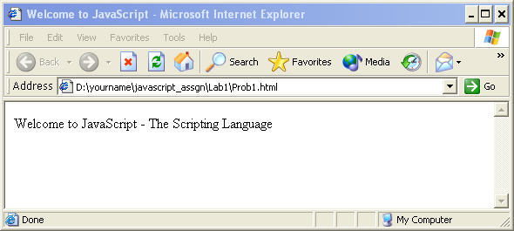
Figure 1: Welcome to JavaScript
Note: Follow the above steps (3 - 8) for every Lab problem for verifying the output. You can also use other text editors like editplus, WordPad, MS Visual Interdev (if installed) to create your html and .js pages.

1.2: Create prob2.html to display Formatted Hello World by using JavaScript by embedding Hello World in <H1> tag.
Solution:
Step 1: Create prob2.html page to complete the following code and save in lab1 directory.
<html>
<head>
<title>Displaying Formatted Text using JavaScript</title>
</head>
<body>

<script>

//TODO: Display hello world embedded in h1 tag with align attribute value right

</script>

</body>
</html>
Example 2: Lab 1: Prob2.html
Step 2: Open prob2.html page in the browser, and verify that you get the same output as required.
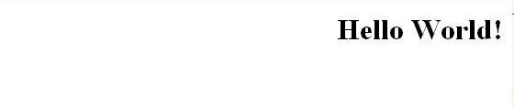
Figure 2: Formatting Text in JavaScript

1.3: Create page to show use of external JavaScript
Solution:
Step 1: Create Prob3.html to complete the following code and save it in lab1 directory.
<html>
<head><title>Using External Script file in HTML Document</title>

<script src="HelloWorld.js">
</script>

</head>
<body>
<hr>
<p>The actual script is in external script file called "HelloWorld.js"</p>

<script>
//TODO: Insert the code here to invoke the function sayHello() in the file HelloWorld.js
</script>

<hr>
</body>
</html>
Example 3: Lab 1: Prob3.html
Step 2: Create a file HelloWorld.js which should have a function sayHello() that returns a string “Hello World”.

function sayHello()
{
//TODO:return the string “Hello World“
}
Example 4: Lab 1: HelloWorld.js
Step 3: Open prob3.html page in the browser, and verify that you get the same output as required.
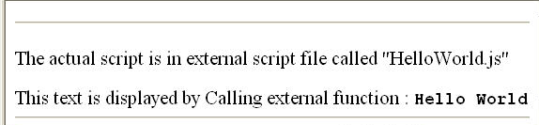
Figure 3: Using external JavaScript File
Step 4: Create Prob4.html page and complete the following code and save it in lab1 directory.
<html>
<head><title>Embedding Script tag in HTML Document</title>

<script>

//TODO:use write method in document object to display the desired output

</script>
<hr>
<script src="Hello.js">
</script>

</head>
<body>

<script>
//TODO: use write method in document object to display desired the output
</script>

<hr>

<p><code>The actual script is in external script file called "Hello.js"</code></p>

<script>
//TODO: Insert your code here to call the function dispHello() from the Hello.js file
</script>

<hr>

</body>
</html>
Figure 4: Lab 1: Prob4.html
Step 5: Create a file Hello.js which should have a function dispHello() that returns a string “Hello World”.
function dispHello()
{
//TODO:return the string “Hello World“
}

Example 5: Lab 1: Hello.js
Step 6: Open prob4.html page in the browser, and verify that you get the same output as required.
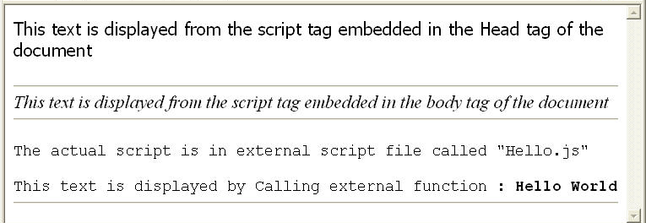
Figure 5: Embedding Script tags in HTML document

1.4: Using Variable in many Script tags
Solution:
Step 1: Create Prob5.html page, and complete the following code and save it in lab1 directory.
<html>
<head><title>Embedding Script tag in HTML Document</title>

<script>
/*
TODO:define variable headVar and initialize it to some integer value and display the value as shown in the Fig 6
*/
</script>

<hr>
</head>
<body>

<script>
/*
TODO:define variable bodyVar and initialize it to some integer value and display the value as shown in the Fig 6
*/
</script>

<hr>
<script src="common.js">
</script>

<script>
/*
TODO: Invoke the method addNos(headVar,bodyVar) defined in common.js file and pass the two variables headVar and bodyVar defined in the head and the body script tag and display the added result as shown in the Fig 6
*/
</script>

<hr>
</body>
</html>
Example 6: Lab 1: Prob5.html
Step 2: Create a file common.js which has a function addNos() that adds two numbers and returns the addition of two numbers.
var msg;
msg="<p><code>The actual script is in external script file called common.js</code></p>";

function addNos(headVar,bodyVar)
{

//TODO: display the contents of the variable "msg"

//TODO: display the addition of two numbers

}
Example 7: Lab 1: common.js

Step 3: Open prob5.html page in the browser, and verify that you get the same output as required.
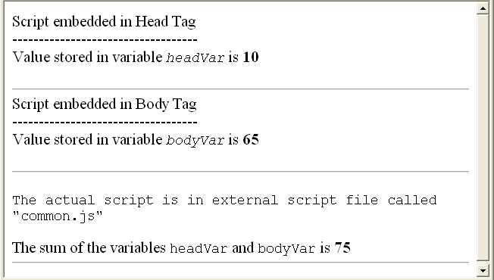
Figure 6: Using Variable in many Script tags
- The JavaScript Language

Goals | - Learn to use looping structures and operators in JavaScript.
Time | 20 minutes

2.1: For loop in JavaScript
Create a web page containing a heading “Layout is here” followed by a horizontal rule and a table with a single row as shown in the figure given below.
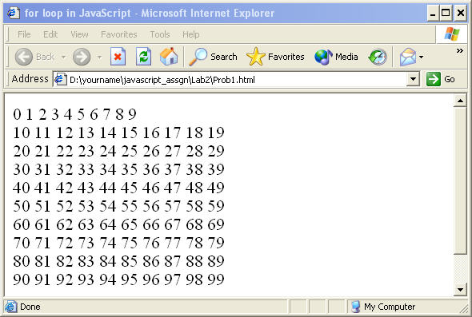
Figure 7: For loop in JavaScript
After completing the loop, the variable used, that is “I”, should be equal to 100.
Solution:
Step 1: Write the code and save it as Prob1.html in lab2 directory.
Step 2: Open prob1.html page in the browser, and verify that you get the same output as required.
Step 3: Create prob1_dowhile.html and prob1_whiledo.html page using do…while and while…do control statements respectively to display similar output as shown in the figure given above.

2.2: Create a web page to calculate the Compound Interest using the formula given below:
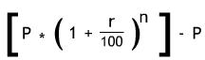
Compund Interest =
Where:
p = Principal,
r = Rate of Interest,
n = period in years
The values used in the example in the following figure are as follows:
P = 1000, n = 1, r = 10

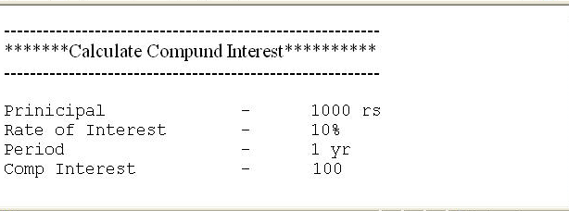
Figure 8: Operators and Arithmetic Expression
Solution:
Step 1: Write the code, and save it in lab2 directory.
Step 2: Open page in the browser, and verify that you get the same output as required.
- Working with Predefined core objects

Goals | Understand Date, String Object  Learn to use Date and String objects in HTML pages
Time | 45 minutes

3.1: Displaying Date using Date Object
Create a web page Prob1.html. In this web page, create a date object and use the getXXXX functions of the date object to display today’s date in the format as shown below in the figure and also greet the user depending on the time the user visits the page. The message to be displayed is given in the following table. The time column shows the current date hour value.

Time | Msg to be displayed
< 12 | Good Morning
>= 12 and <= 17 | Good Afternoon
> 17 | Good Evening

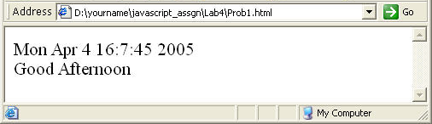
Figure 9: Displaying Date using Date Object
Solution:
Step 1: Write the Code, and save it as Prob1.html in lab4 directory.
Step 2: Open prob1.html page in the browser, and verify that you get the same output as required.

3.2: Using indexOf function of String object
Create a web page prob2.html, which uses the indexOf method of string object and displays the index number of the substring searched for within the string.

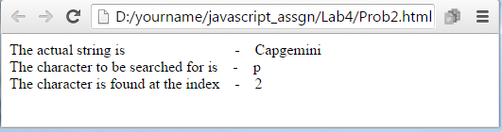
Figure 10: Using indexOf method of String object
Solution:
Step 1: Write the Code and save it as Prob2.html.
Step 2: Open prob2.html page in the browser, and verify that you get the same output as required.

3.3: Using various String methods
Write prob3.html page by completing the following code that demonstrates some of the methods of the String objects like match, substr, lowerCase, and upperCase to produce the output as shown in the figure given below:
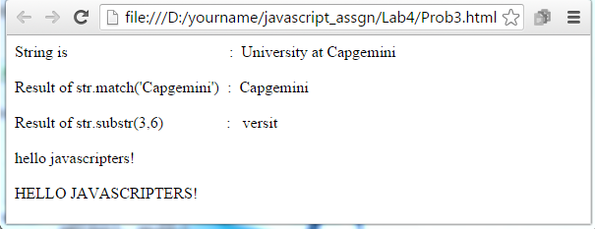
Figure 11: Using various String methods
Solution:
Step 1: Write the Code and save it as Prob3.html.
Step 2: Open prob3.html page in the browser, and verify that you get the same output as required.
- Working with Arrays

Goals | Work with Array Object
Time | 10 minutes

4 .1: Using Array to display values
Create a prob1.html web page containing script. In this script, declare an array of 6 employee names and display it in the browser as shown below:

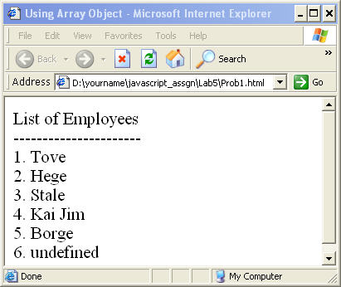
Figure 12: Using Array to display values
Solution:
Step 1: Write the Code, and save it as Prob1.html.

Step 2: Open prob1.html page in the browser, and verify that you get the same output as required.

- Working with Document Object Model(DOM)

Goals | Understand Window Object  Dynamically create windows  Handle window events
Time | 90 minutes

5 .1: Window object
Create a prob1.html web page which has the following items as shown in the figure given below:
- a form that accepts window parameters width, height, title, left and top parameters from text field, and
- two buttons with the labels New Window and Reset to the web page

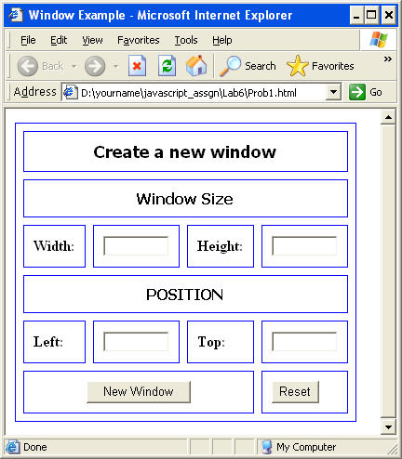
Figure 13: Interface to accept window coordinates

If Reset button is clicked, then clear all text fields. If New Window button is clicked, then open a new window with specifications entered in the text fields as shown in the figure given below.
Note: By default, the new window opens at the top left corner of the screen.
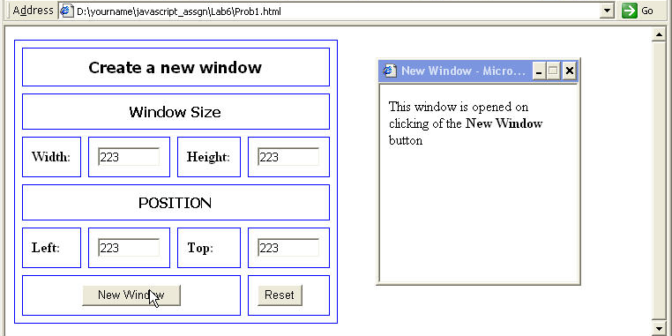
Figure 14: Opening a window
Solution:
Step 1: Complete the following Code and save it as Prob1.html.
<html>
<head>
<title> window example </title>
</head>
<script>
function nwindow()
{
/*TODO: get the height, width, left and top from the form object and pass the values to open method of window along with the name of the html file to be opened in the new window.*/
}
</script>
<body >
<form id="frmlab">
<table border="1" cellspacing="8" cellpadding="10" bordercolor="blue">

// Create Table as shown in fig 6.2
</table>
</form>
</body>
</html>
Example 8: Lab 5: Prob1.html
Step 2: Open prob1.html page in the browser, and verify that you get the same output as required.
Step 3: Open prob2.html page in the browser, and verify that you get the same output as required.
- Working with Location Object

Goals | Understand and use Location Object.
Time | 20 minutes

6.1: Location Object
Create a web page which will display the properties href, protocol, and the pathname of the location object of your current file.
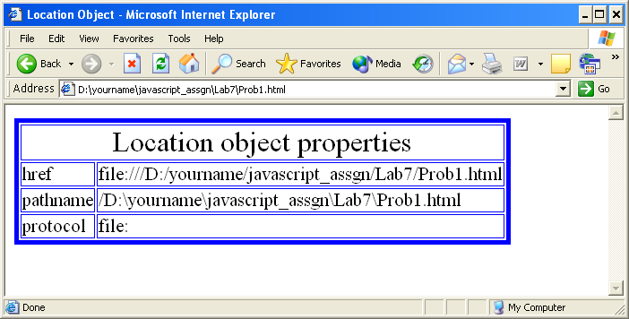
Figure 15: Location Object Properties
Solution:
Step 1: Write the code and save it as Prob1.html.
Step 2: Open prob1.html page in the browser, and verify that you get the same output as required.
- Working with Document Object

Goals | Understand Document Object
Time | 120 minutes

7.1: Working with Documents
Create a prob1.html web page which displays products available as shown in the following figure. The product details comprise Product Name, Product description, and its price.
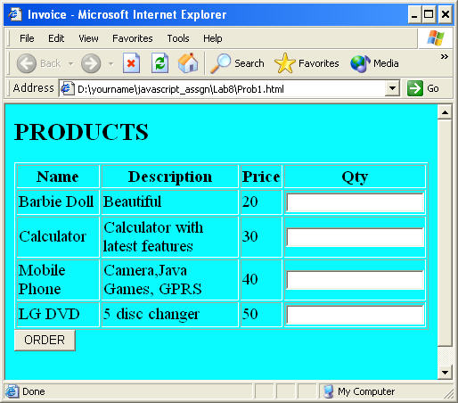
Figure 16: Displaying Products
Users can place orders specifying the quantity of each product. If the user does not enter quantity in any of the text fields, then an error message should be displayed as shown in the figure given below:

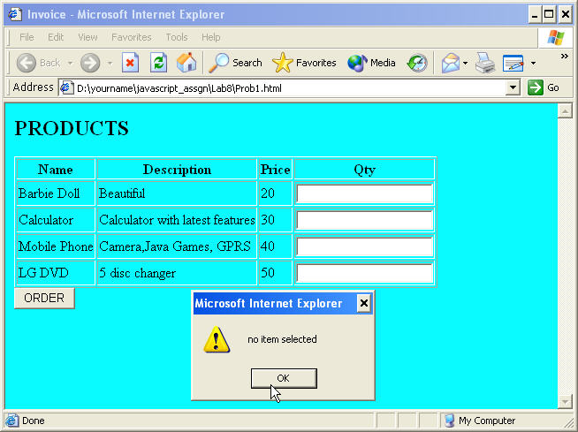
Figure 17: Validating Products
When the user clicks the Order button, the invoice for the current products transaction showing the product name, quantity ordered, price and total amount is displayed in a new window as shown in the figure given below:
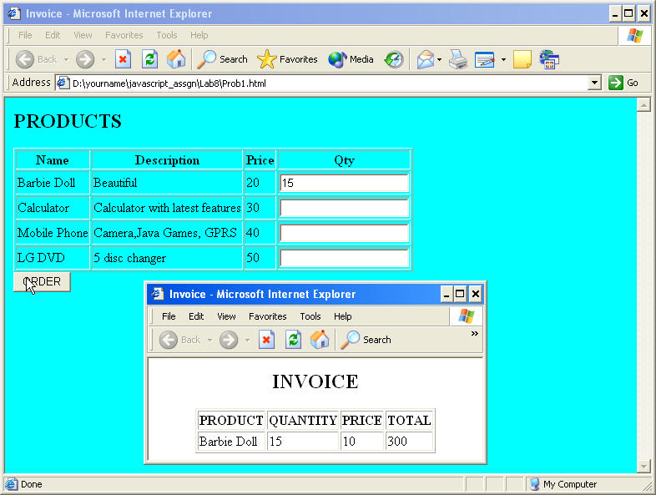
Figure 18: Displaying Invoice details in a new window
Solution:
Step 1: Write the code and save it as Prob1.html.
Step 2: Open prob1.html page in the browser, and verify that you get the same output as required.
- Working with Form Object

Goals | - Understand and use Form Object.
Time | 90 minutes

8.1: Form Validation
Create a prob1.html web page, as shown below, and calculate Payment Information based on Loan Information. Validate Loan information textfields for numbers. The Payment Information textfields should be uneditable. The other constraints are as follows:
- Amount of Loan should not be more than 15 lakhs.
- Repayment period should be between 7 yrs to 15 yrs.
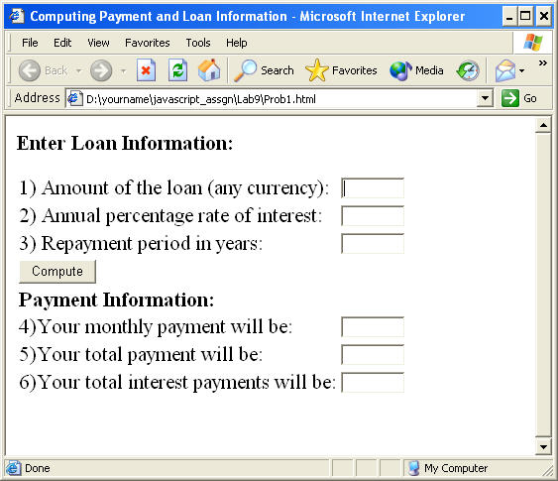
Figure 19: Validating Form elements

If the repayment period is not between 7 and 15, then an error message should be displayed next to this control.
Similar kind of error message should be displayed if the amount of loan exceeds 15 lakh.
In the function calculatePayment()
/*
TODO:
calculate the monthly payment, total payment, total interest payment on click of the button with label "compute"
*/
Example 9: Lab 8: Prob1.html
Open prob1.html page in the browser, and verify that you get the same output as required.

8.2 Validate Field
Create a prob2.html page as shown in the below figure.
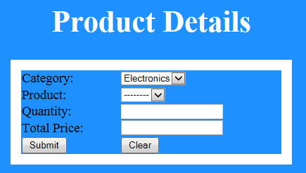
Figure 20: Lab 8.2 Product Details
Data should be prepopulated in category list box (Electronics, Grocery). Based on selection of category, product list need to be populated automatically with values as given in the below table. Also Total price need to be calculated for the entered quantity as per the data in the below table. Total price field should be non-editable field.

Category | Product | Price per quantity in Rupees
Electronics | Television | 20000
Electronics | Laptop | 30000
Electronics | Phone | 10000
Grocery | Soap | 40
Grocery | Powder | 90

While clicking on submit button, if all the text fields contains valid values then display the filled details in a popup window.

- Regular Expressions in JavaScript

Goals | - Understand Regular Expression object  - Use Regular Expression object for validating
Time | 90 minutes

9.1: Regular Expression
Create a prob1.html page which has two text fields – one for the Regular Expression search pattern and the other for the string in which the pattern has to be checked.
The form has two buttons one “Test Match” and the other “Show Match”.
Test Match will test the regular expression against the string. Show Match will show the matching part of the string.
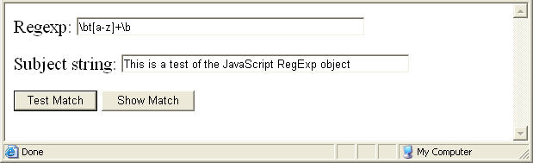
Figure 20: Regular Expression Pattern

Type the regular expression in the first textbox and the string in the second text box. Click the “Test Match” button.
If the text in the second text box matches the Regular Expression in the first text box, then it should display a message as shown below.
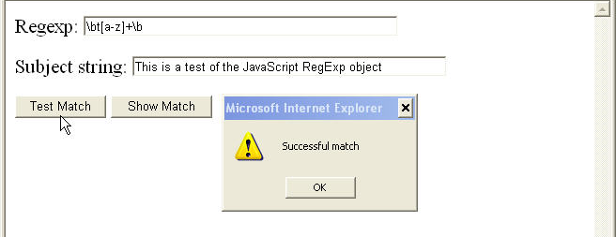
Figure 21: Validating Regular Expression Pattern
If you click the “Show Match” button, then it should display the match as shown in the figure given below:

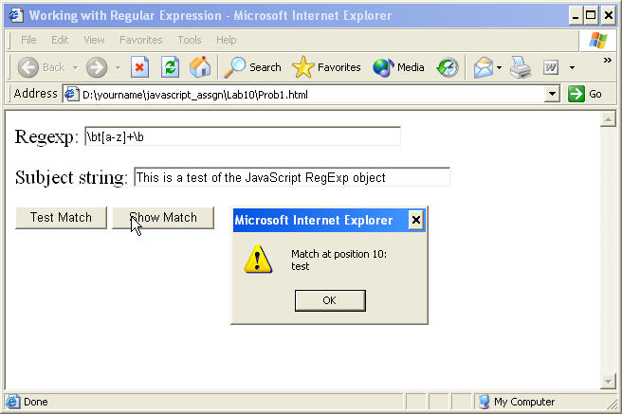
Figure 22: Displaying text matching Regular Expression Pattern
Solution:
Step 1: Write the Code and save it as Prob1.html.
Some Tips

In the function demoMatchClick()
/*
TODO:
define a variable re which is the regular expression object, to which the regular expression pattern is passed as an argument. define a variable str which holds the string from subject field match the "str" with "re" using the match method of the string object and display appropriate messages
*/

In the function demoShowMatchClick()
/*
TODO:
Store the regular expression pattern in a variable "re" and invoke exec method of regular expression object which takes the matching string as argument and returns the index of the matching string found
*/
Example 10: Prob1.html
Step 2: Open prob1.html page in the browser, and verify that you get the same output as required.

9.2: Form Validation using Regular Expression
Create a prob3.html page as shown in the below figure. Use CSS for designing page The page should be submitted on clicking the Submit button when all the form fields are properly validated.
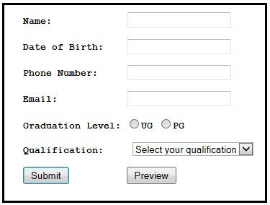
Figure 23: Form Validation using Regular Expression
- None of the fields should be empty ( Use HTML 5 attributes )
- Name field should be between 3 to 10 characters ( Use HTML 5 attributes )
- Date of Birth format can be either (DD/MM/YY or DD/MM/YYYY) ( Use HTML 5 date control )
- Phone Number should be in xxx-xxxx-xxxx format ( Use HTML 5 attributes )
- Email ID should be valid. ( Use HTML 5 attributes )
- Based on graduation level selected, qualification need to be populated automatically. For an example, if graduation level selected is UG, then qualification should be B.Sc, B.A, B.Com, etc... If graduation level selected is PG, then qualification should be M.A, M.Tech, MCA, MBA, etc… ( Call function on onChange event )
- Calculate age of the person and display all the details in a new popup window when “Preview” button is clicked. Details should be printed in the specified format as given below:
Name:
Age:
Phone Number:
Email:
Graduation Level:
Qualification:
Display the appropriate error message when the condition fails.

Appendices

Appendix A: JavaScript Standards
- Naming conventions for variables in JavaScript:
- Variables must begin with prefix indicating the type of the variable.
- All integer must start with "int".
- All floating data types must start with "flt".
- All string must start with "str".
- All object name must start with "obj".
- All Boolean variables must start with "bln".
- All variables that store date must start with "dt".
- All constants must be in upper case with different words separated by underscore ( _ ).
- All array variables must start with "arr".
- Apart from these guidelines all variable name must be sensible enough, so that it’s purpose can be identified from it's name.
Type | Example
String | strStringName
Boolean | blnPresent
Array | arrArrayName
Object | objObjectName
Date | dtDateName
Integer | intValueInteger
Float | fltValueFloat
Constants | STRING_CONSTANT  ARRAY_CONSTANT  NUMERIC_CONSTANT

- All HTML elements must be prefixed with appropriate types.
- TextBox "txt”
- Image "img"
- Image map Area “img”
- option button "opt"
- CheckBox "chk"
- DropDown List "lst"
- Form Name "frm"
- Buttons "btn"
- All div tags "div"
- All class names must start with "cls"
- All user-defined objects must start with "u"
- First letter of each variable/function name must be in upper case. Rest all letters must be in lowercase.
- Use of underscore and digits for naming variables must be avoided.
Tag | Example
Div | divContent
Class | clsInterest
Form | frmContainer
Image | imgMapThis
Button | btnOk
TextBox | txtInterestRate
CheckBox | chkAllow
Option Button | rdbRate
DropDownList | lstState

It must be noted that this naming style does not apply to HTML elements. However, when these elements are accessed in the JavaScript functions, these naming conventions must be followed. This document describes coding convention only for JavaScript.

- Commenting
- Comments related to a particular line of code should be on the same line after the statement gets over.
If (dtToday == “15/07/99”) { // Is date birthdate?
alert (“Happy Birthday”); // Give birthday message
} else {
alert (“Happy Day”); // Give standard message
}

- Over all commenting should consist of two parts – Comment header and Comment footer. Comment header must precede the block of code and Comment footer must follow the block of code.

//Function Name:  //Description:  //  //  //  //  //  //Author:  //Start Date:  //Input Parameters:  //  //Return Value: | calculateInterest  This function calculates the interest. It accepts the initial investment and period for which the amount is invested. Rate of interest is fixed. Formula is  fltInterest = fltAmount * fltPeriod *fltRATE/100  Dhrumil Dalal  15/07/1999  fltAmount – indicated the amount invested  fltPeriod – Indicates the period of investment  Calculated interest
Function calculateInterest(fltAmount,fltPeriod){
}

//End of function for calculating the rate of interest
- Documentation
- All variables used in the function must be declared in brief.
- Only one variable declaration per line.
- Describe each variable on the same line and description should not be more than one line.
- All functions must be preceded by comments. Comments must describe the following:
- Input parameters.
- Return value.
- Function logic in brief.
- Starting date.
- Name of the author.
- Revision history.
- After the end of function, there must be block of comment indicating the end of function.

//Function Name:  //Description:  //  //  //  //  //  //Author:  //Start Date:  //Input Parameters:  //  //Return Value: | calculateInterest  This function calculates the interest. It accepts the initial investment and period for which the amount is invested. Rate of interest is fixed. Formula is  fltInterest = fltAmount * fltPeriod *fltRATE/100  Dhrumil Dalal  15/07/1999  fltAmount – indicated the amount invested  fltPeriod – Indicates the period of investment  Calculated interest
Function calculateInterest(fltAmount,fltPeriod){
Var fltRATE = 12.5; // fixed rate of interest
Var fltInterest; // The variable to store calculated interest
fltInterest = fltAmount * fltPeriod * fltRATE/100 ;
return fltInterest;
}

//End of function for calculating the rate of interest

- 4: Coding Styles
- For statements which may have block of code enclosed in {}, the opening brace "{" must immediately follow the statement and the closing brace "}"must be below the statement. That is to say, the closing brace and first letter of the statement must be same in the column.

If (condition) {
...
} else {
if (condition) {
...
} else {
...
}
}

for(intCounter=0; intCounter <= 5; intcounter++){
//Perform calculation.
//Display Result}

- All statements within corresponding opening and closing brace must be indented. Indentations must be in odd columns.

Column no
123456789…………………………………………………………………………
if (condition) {
...
} else {
if (condition) {
...
} else {
...
}
}

- Also the code should not extend past the 80th column so that it is required to scroll to the right or left to edit a particular line. In the case of strings which do not fit on one line, it is recommended that temporary variables be used with the string concatenation operator (+=) to construct strings of longer lengths. The following example illustrates this:

Column no
123456789…………………………………………………………………80
strMessage = “Demonstrating the use of … “;
strMessage += “prepared on 15-07-1999”;

Appendix B: Coding Best Practices
JavaScript Best Practice
The following demonstrate the best practices that should be followed while writing JavaScript code.
- Inline JavaScript source code
Any JavaScript code that does not write out to the document should be placed within the head of the document.
<HTML>
<HEAD>
<SCRIPT>
<!--
function functionName() {
alert(text);
}

var text = 'Hello World';
//-->
</SCRIPT>
</HEAD>
Example 11: Sample Code
This ensures that the browser has loaded the JavaScript function definitions before it is required. It also makes it slightly easier to maintain the JavaScript code if it can always be found in the head of the document.

- JavaScript Links
Avoid using the javascript: protocol as a default URL within a link.
If JavaScript is disabled, then the link will not work. Do not use the following:

<SCRIPT>
<!--
function functionName() {
alert('Hello world');
}
//--></SCRIPT>
<A HREF="javascript:functionName()">text link</A>
Example 12: Sample Code
Instead, use JavaScript itself to override the href property of the link:
<SCRIPT>
<!--
function functionName() {
alert('Hello world');
}
//-->
</SCRIPT>

<A HREF="default.htm" onClick="this.href='javascript:functionName()'">text link</A>
Example 13: Sample Code
- Avoid Using Void
All browsers do not support the void function. Create your own void function.
The in built void() function is supported since JavaScript 1.1. Therefore it is best to create your own void function rather than rely on JavaScript 1.1 being available.
<SCRIPT>
<!--
function myVoid() { } // create a void function
//-->
</SCRIPT>

<A HREF="#" onClick="this.href='javascript:myVoid()'">non functional text link</A>
Example 14: Sample Code

- JavaScript Performance
Avoid writing output multiple times to the document, concatenate the data, and then write all in one go.
With the introduction of Netscape Navigator 4, the rendering of JavaScript generated HTML slowed down considerably.
The following writes the HTML output to the document in one go:
<SCRIPT>
<!--
var output = '<P>';
output += 'Last modified: ';
output += document.lastModified;
output += '<\/P>'
document.write(output);
//-->
</SCRIPT>
Example 15: Sample Code
- Select Form Fields
Use the Netscape method to correctly navigate select field properties.
The following technique works in Microsoft Internet Explorer. However it should be avoided.
<SCRIPT>
<!--
var property = document.formName.selectName.propertyName
//-->
</SCRIPT>
Example 16: Sample Code
Whereas the following will work correctly in all browsers:
<SCRIPT>
<!--
var property = document.formName.selectName.options[document.formName.selectName.options.selectedIndex].propertyName
//-->
</SCRIPT>
Example 17: Sample Code
- Changing Location
Do not use the following:
<SCRIPT>
<!--
location = 'page.htm';
//-->
</SCRIPT>
Example 188: Sample Code
The later approach is confusing as it is not clear whether you are changing the location property of the “window” or the “document object”.
Changing the location using the document is deprecated and causes problems on later browsers. Use the following:
<SCRIPT>
<!--
window.location.href = 'page.htm';
//-->
</SCRIPT>
Example 19: Sample Code
- Opening Windows
While opening a new popup window using JavaScript, there are several points to bear in mind.
To be able to control the popup window from the opener window, always retain the returned reference from the window's open method:

<SCRIPT>
<!--
var windowHandle = window.open('page.htm','windowName','width=600,height=320');
//-->
</SCRIPT>
Example 19: Sample Code
To avoid errors while referring to the opener window from the popup window, always check for the in-built browser support for the opener property. If necessary, provide your own:
<SCRIPT>
<!--
var windowHandle = window.open('page.htm','windowName','width=600,height=320');
if (!windowHandle.opener)
windowHandle.opener = self;
//-->
</SCRIPT>
Example 20: Sample Code

While updating the contents of a newly opened window, give the browser time to open the window and to load the initial contents:
<SCRIPT>
<!--
function update() {
windowHandle.document.open();
windowHandle.document.write('<H1>Hello World<\/H1>');
windowHandle.document.close();
}

var windowHandle = window.open('page.htm','windowName','width=600,height=320');
if (!windowHandle.opener)
windowHandle.opener = self;
setTimeout('update()',2000);
//-->
</SCRIPT>
Example 21: Sample Code
- JavaScript Entities
JavaScript Entities are only supported by Netscape Navigator. Avoid their use.
The following will cause errors in other browsers:

<HR WIDTH="&{barWidth};%">

Example 22: Sample Code
Instead the following can be used.

<SCRIPT>
<!--
document.write('<HR WIDTH="' + barWidth + '%">');
//-->
</script>
Example 23: Sample Code

Appendix C: Table of Figures
Figure 1: Welcome to JavaScript 7
Figure 2: Formatting Text in JavaScript 8
Figure 3: Using external JavaScript File 9
Figure 4: Lab 1: Prob4.html 10
Figure 5: Embedding Script tags in HTML document 10
Figure 6: Using Variable in many Script tags 13
Figure 7: For loop in JavaScript 14
Figure 8: Operators and Arithmetic Expression 15
Figure 9: Displaying Date using Date Object 16
Figure 10: Using indexOf method of String object 17
Figure 11: Using various String methods 18
Figure 12: Using Array to display values 19
Figure 13: Interface to accept window coordinates 20
Figure 14: Opening a window 21
Figure 15: Location Object Properties 23
Figure 16: Displaying Products 24
Figure 17: Validating Products 25
Figure 18: Displaying Invoice details in a new window 25
Figure 19: Validating Form elements 27
Figure 21: Regular Expression Pattern 30
Figure 22: Validating Regular Expression Pattern 31
Figure 23: Displaying text matching Regular Expression Pattern 31
Figure 27: Form Validation using Regular Expression 32

Appendix D: Table of Examples

Example 1: Lab 1: Prob1.html 6
Example 2: Lab 1: Prob2.html 7
Example 3: Lab 1: Prob3.html 8
Example 4: Lab 1: HelloWorld.js 9
Example 5: Lab 1: Hello.js 10
Example 6: Lab 1: Prob5.html 12
Example 7: Lab 1: common.js 12
Example 8: Lab 5: Prob1.html 22
Example 9: Lab 8: Prob1.html 28
Example 10: Prob1.html 32
Example 11: Sample Code 41
Example 12: Sample Code 42
Example 13: Sample Code 42
Example 14: Sample Code 42
Example 15: Sample Code 43
Example 16: Sample Code 43
Example 17: Sample Code 44
Example 18: Sample Code 44
Example 20: Sample Code 45
Example 21: Sample Code 45
Example 22: Sample Code 46
Example 23: Sample Code 46
Example 24: Sample Code 46

